|  |  |
| --- | --- |
| Run 2 Modulus | 49.028 kpsi |
| Run 2 Yield Strength | 89.9 kpsi |
| Run 2 Ultimate Strength | 92.53408 kpsi |

|  |  |
| --- | --- |
| Run 3 Modulus | 61.165 kpsi |
| Run 3 Yield Strength | 87.6 kpsi |
| Run 3 Ultimate Strength | 92.96919 kpsi |

|  |  |
| --- | --- |
| Run 4 Modulus | 60.107 kpsi |
| Run 4 Yield Strength | 72.1 kpsi |
| Run 4 Ultimate Strength | 81.36617 kpsi |

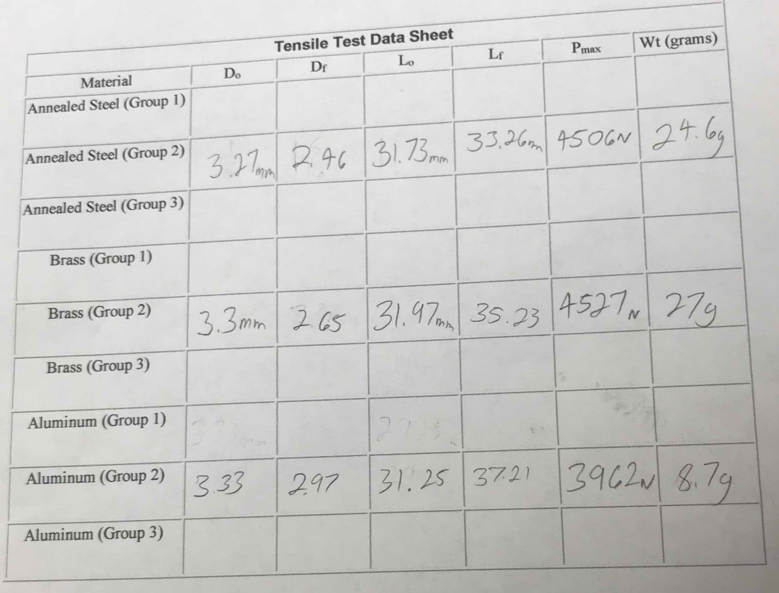

Some feedback:

* I didn’t know which data set on moodle was for which material, so I assumed they were taken in the order on the test data sheet
* I could not figure out how to draw the 0.2% yield strength trendline using built-in excel chart functions, so I drew it manually to the best of my ability as far as precision goes.